MID-TERM LISTENING TEST- A2

INFORMATION FOR CANDIDATES
There are five parts to this test. You will hear each part twice. For each part of the test there will be time for you to look through the questions and time for you to check your answers. At the end of the test, there is an extra time of 8 minutes for you to transfer your answers onto the answer sheet.

PART 1: Questions 1-5
You will hear five short conversations. There is one question for each conversation. For questions 1-5, put a tick (✓) under the right answer.
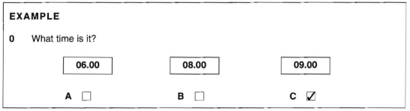

- What was the weather like on Wednesday?
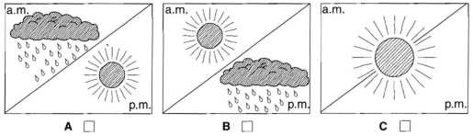
- How much did Mark’s pullover cost?

- What did Raquel buy today?
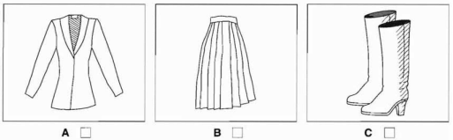
- How many students are there at the college?
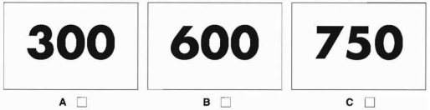
- What is David going to buy?
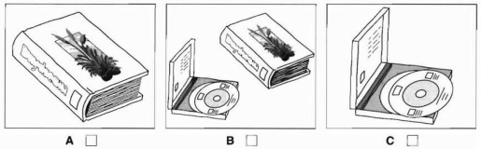
PART 2: Questions 6-10
Listen to Philip talking to his mother about his son, Simon. What is Simon going to do on Saturday and Sunday? For questions 6-10, write a letter A-H next to each time.
Example:
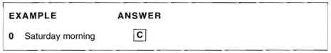
Times Things to do
6 Saturday afternoon |  | A bicycle ride
7 Saturday evening |  | B football match
8 Sunday morning |  | C judo
9 Sunday afternoon |  | D party
10 Sunday evening |  | E swimming
 |  | F the cinema
 |  | G the park
 |  | H watching television

PART 3: Questions 11-15
Listen to Chloe talking to a man about a sailing holiday .For questions 11–15, tick ✓A, B or C.

11 How many times has Chloe been sailing before? | A | never | 
 | B | once | 
 | C | twice | 
12 How much can Chloe spend? | A | £300 | 
 | B | £380 | 
 | C | £450 | 
13 Chloe will go in | A | August. | 
 | B | September. | 
 | C | October. | 
14 Chloe would like to sail on | A | a lake. | 
 | B | the sea. | 
 | C | a river. | 
15 How does Chloe want to pay? | A | By cheque | 
 | B | With cash | 
 | C | By credit card | 
PART 4: Questions 16-20
You will hear Kate and Jeremy talking about a party.
Listen and complete questions 16-20.
KATE’S BIRTHDAY PARTY
Kate will be: |  | 17 years old
Day: | 16
Time: | 17
Place: | 18
Address: | 19 | .........................…........….Street ……………………………
Bring some: | 20

PART 5:Questions 21-25
You will hear some information about a cinema.
Listen and complete questions 21-25.
CINEMA
Name of cinema: |  | North London Arts Cinema
Next week’s film: | 21 | .......................................Meeting
from: | 22 | Monday to ..................................
times: | 23 | 6.45 p.m. and .............................
Student ticket costs: | 24 | £ ……………………………..
Nearest car park: | 25 | ...........................................Street

